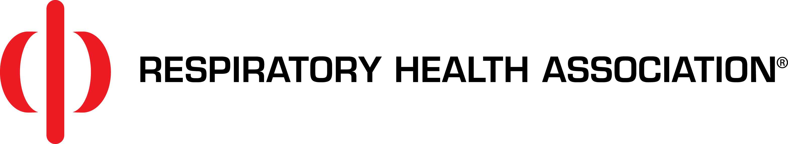
HEADLINE: Protect your tenants – and your investment
BODY: If someone smokes in your property, you know how serious the damage is. Your carpet is burned, your walls are stained, and your unit stinks. Secondhand smoke is hard on your investment, so imagine what it does to your tenants!
In a multi-unit building, 35 to 65 percent of the air in any given unit is shared air from other units and common areas. That means if just one tenant smokes, all of your tenants suffer the consequences, including an increased risk of heart attacks, stroke and lung cancer. Plus, children exposed to secondhand smoke have an increased risk of asthma attacks, infections and SIDS.
You can protect your tenants’ health and your investment by making your properties smoke-free. Going smoke-free doesn’t mean that you don’t allow residents who smoke. Simply put, a smoke-free building is one in which smoking is not permitted indoors, including in any units or common areas. Adopting a smoke-free policy is legal, profitable and easy.
Smoke-free policies are legal. Just like your policies regarding noise and pets, you can enact policies to prohibit smoking to create a better, safer living environment for your tenants. In fact, the U.S. Department of Housing and Urban Development has strongly encouraged property owners and managers to adopt smoke-free policies.
Smoke-free policies are profitable. Compared with a unit where smoking is allowed, smoke-free units cost significantly less to turn over. Plus, a poll commissioned by Respiratory Health Association found that more than 40 percent of Chicago renters would be willing to pay more to live in smoke-free housing.
Smoke-free policies are easy. Developing and implementing a smoke-free policy takes minimal effort and produces maximum results for you and your tenants. And once implemented, smoke-free policies are generally self-enforcing and require little staff time.
When you’re ready to get started, Respiratory Health Association is here to help. We’ve worked with multiple public housing agencies, private developers and community organizations to transition properties to being smoke-free. We can help you with sample lease language, resident surveys, free smoking cessation resources and fact sheets.
For more information, contact Matt Maloney at Respiratory Health Association: MMaloney@lungchicago.org or (312) 628-0233.

